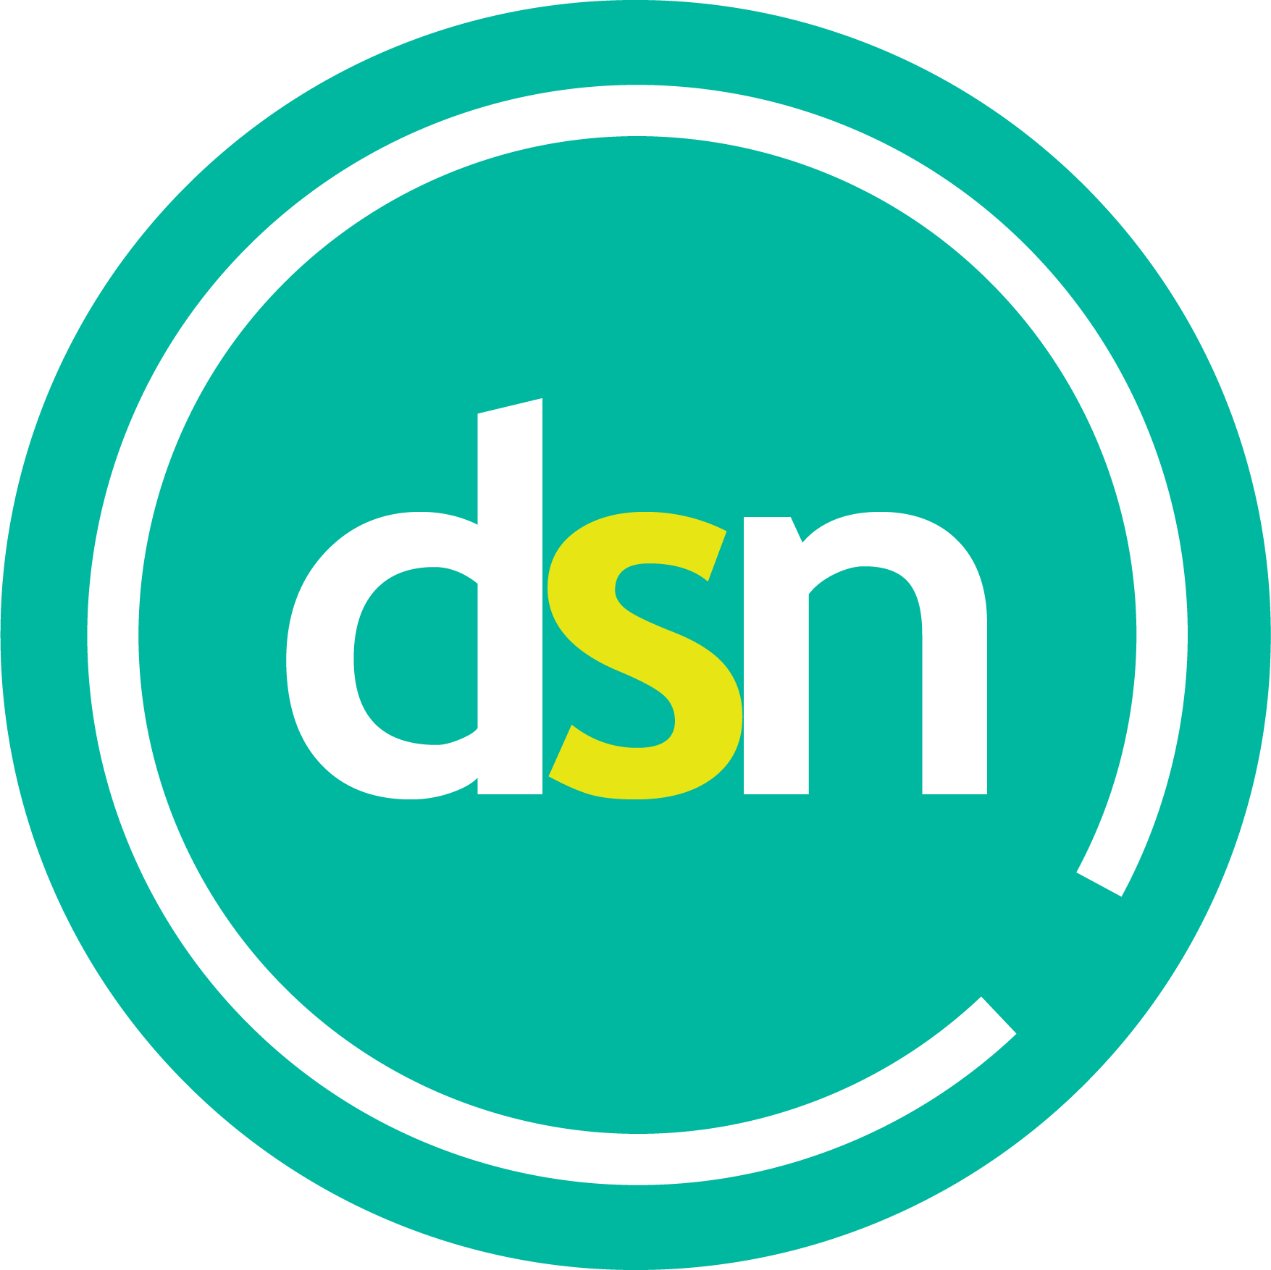
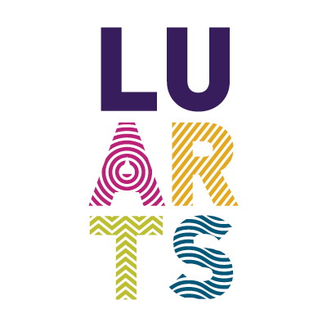

What my disability can do!
An arts project from LU Arts and LSU Disability Support Network (DSN).

Brief
The DSN is here to support and develop the community of students on campus who self-identify as either living with a visible or invisible disability. Working with LU Arts, we have developed a competition that gives students a platform to express their talents and communicate important issues about disability.
This project aims to educate and raise awareness of all disabilities on campus. It allows students to share their artwork as well as promoting accessibility, inclusivity, and community themes.
We would like you to submit a piece of original art (illustration, painting, photography, graphic design, or drawing), responding to the title ‘What my disability can do!’.
Here are some ideas you could explore:
- What does disability mean to you?
- Surpassing other people’s expectations based on your disability.
- Envision an experience where you/others have challenged/inspired/profited from their disability.
- Create an informative graphic to help raise awareness of a selected disability.
- Draw around yourself or someone else and capture your thoughts, feelings and experiences within this outline.
Following judging, selected entries will be showcased on LU Arts’ website and LU Arts and DSN’s social media channels. Some of these works may also be printed and displayed in key buildings on campus and presented on digital screens.

Prizes
We are offering three cash prizes:
1st Prize: £150
2nd Prize: £100
3rd Prize: £50
The winner and runners-up will have their work displayed in the bus shelters on campus as well as being showcased on LU Arts’ website and LU Arts and DSN’s social media channels.

Who can enter?
This competition is open to any current student at Loughborough University who identifies themselves as disabled including PGT and PGR students, and Loughborough University London students.

How to enter
Please complete the application form below and email it to luarts@lboro.ac.uk. Don’t forget to attach your artwork to this email! Your artwork should be produced in portrait/vertical format and submitted as a jpeg. If you need help submitting your artwork, then please let us know. For example, we can scan or photograph it for you. Please email luarts@lboro.ac.uk or telephone 01509 222948 for help with this.
Art form outputs: original artworks (e.g. paintings or drawings), illustrations, photography, or graphic design, which may include text/poetry elements. Due to the way in which selected artworks will be displayed it is important that you produce your work in portrait orientation/vertical format.
By submitting your artwork and entering this competition, you are giving your consent for it to be published on LU Arts’ website, LU Arts and DSN’s social media channels and displayed on Loughborough University’s two campuses. Work can be displayed anonymously if you would prefer this.

Accessibility
We want this opportunity to be accessible to all students. If you would like to discuss any accessibility issues before you enter or need further support, then please email luarts@lboro.ac.uk or call 01509 222948. We will accept applications in different formats e.g. audio or large print if this is more appropriate for you.

Judging
The judging panel will be:
Neve Fields, DSN Chair and Disability Officer
Maeve Callaghan, DSN Media Officer
DSN Committee Panel
Jenny Ardley, Staff Inclusivity Group representative
Nick Slater, Director, LU Arts
As well as selecting the winner and two runners-up, the judging panel will draw up the shortlist of entries to be showcased (on campus and online). This will give these artists visibility, help raise awareness and contribute to their employability.

Timescales
Deadline for entries: 5pm on Monday 16 May 2022
Bus shelter and campus displays: June 2022

WHAT MY DISABILITY CAN DO!
APPLICATION FORM

Name:
Term-time address:
Student number:
Course, and current year of study for 2021/22:
e.g. BSc Geography, 2nd year
At which campus is your degree based? (Loughborough or London)
University e-mail address:
Phone number:
Title of your artwork:
Tell us a little bit about your work:
Please note that we may publish this alongside your work if you are shortlisted, but we will check with you first.
Tell us about yourself and your relationship with the brief:
Please note that we may publish this alongside your work if you are shortlisted, but we will check with you first.
LU Arts and/or DSN may produce photo and video material about your entry for promotional purposes. By typing XXX in the box below, you give consent for your image to appear in this footage, which might include use on the LU Arts website, social media and in wider Loughborough University materials. |  | Type XXX to confirm your consent:

If you have any questions before you apply, then please email luarts@lboro.ac.uk. Please return your completed application form to luarts@lboro.ac.uk by 5pm on Monday 16 May 2022. Please put ‘What my disability can do! in the subject line of your email and attach your artwork to this email.

