Student Module Feedback Questionnaire Update for LTC December 2012

1. Introduction
An updated ‘Appendix 13’ to the Academic Quality Procedures Handbook – Code of Practice for Student Module Feedback Questionnaires – was agreed by LTC (and by extension Senate and Council) during 2011-12, and is available via:
http://www.lboro.ac.uk/admin/ar/policy/aqp/appendix/13/index.htm
Key changes included: clauses 14 and 15, regarding collation of responses to questions 1-12, and their circulation to Staff-Student Liaison Committees (SSLCs) and LSU VP Education, in addition to appropriate academic colleagues; and clause 18 requiring submission of all feedback questionnaires to the Print Unit within one week of the end of the semester in question, with results processed and available on-line within a further week, in order to give maximum opportunity to inform changes and updates.

2. Progress towards fulfilling the new policy
It was to be expected that there would be a ‘learning curve’ in implementing the new code.
Anecdotal feedback via student channels suggests that collated questionnaire responses as above have not been received by SSLCs and LSU VP Education in every case.
The table below shows that around 7% of feedback questionnaires were received and processed by the Print Unit well after the Code of Practice deadline. Many came in after the start of this academic year – too late for any lessons learnt to be learnt to applied to this year’s teaching
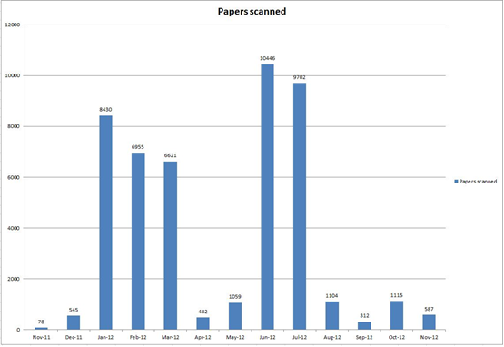
Fig 1 – Return of Student Feedback Questionnaires to Print Unit summer 2012

Action: LTC support is requested to invite colleagues to be mindful of timings for returning questionnaires to the Print Unit, and of the need for collating responses for SSLCs and LSU VP Education as per the code.
4. Further background information on questionnaire system
A pragmatic ‘cut-off date’ of 16 November 2012 was circulated to School staff: all questionnaires received before then are treated as from Semester 2 2011/12; all questionnaires received thereafter were assumed to be from Semester 1 2012/13. This approach ensures that PGT and other feedback legitimately sought in September and October, right at the end of the academic year, will be analysed in the correct year.
The content of questions this year has been updated by the Teaching Unit, and communicated to all relevant School staff.
A ‘year roll-over’ function has been added to the LUSI reporting on questionnaires, allowing previous years’ reports (and questions) to be accessed.
LUSI reporting is now available ‘by programme by module’. A further report, to average core questions by programme over all modules taught in that programme, is being prepared, and will go on line in the new calendar year.
Organisers of Distance Learning modules where the primary mode of content delivery is paper are being encouraged to send paper questionnaires with learning materials, to be returned and submitted to the Print Unit in the usual way.
In the case of Distance Learning Modules that are primarily mediated on-line, ITS staff are working on a pilot with WEDC to use an on-line version of the standard questionnaire. Results will be fed into LUSI, and will be available via LUSI reporting, in the usual way.

5. Project and dissertation evaluation forms
Despite a large amount of time being invested by ITS etc. in preparing variants of the module system for the above, none were in the event used by Schools during 2011/12. It is noted that all projects and dissertations must be embedded within modules, and that the Code of Practice requires evaluation at the module level. It is suggested that in future, projects and dissertations are evaluated as part of the module they sit within, with optional questions used as appropriate to probe specific project/dissertation issues.
Action: LTC support is requested to discontinue stand-alone project/dissertation evaluation, and focus on module evaluation as per the Code of Practice.

6. Retention of paper questionnaires
Last year, paper questionnaires were kept by the Print Unit and then returned to Schools. This created large additional workload in the Print Unit, and possibly in Schools. Given that the new system has proved robust, and all results including free text responses are accessed and retained on LUSI, it is suggested that no useful purpose is served in retaining the paper questionnaires and returning them to Schools once they have been scanned.
Action: LTC support is sought to allow the Print Unit to dispose of all paper questionnaires as confidential material once they have been safely scanned into LUSI.

Phil Richards, Alison Freer, Caroline Smith, Dawn Fendell, Janet Hague, Mark Ramsay, Richard Goodman, Time Baseley
November 2012

