Minimum Online Presence Audit October 2012

Background
In 2012 a new ‘Minimum Module Online Presence’ was agreed by the E-learning Advisory Group (ELAG) and LTC, replacing the previous version which had been in place since 2008. (See Appendix 2.) The new version introduced modest additional requirements, notably around the use of the University Reading List System, the General Announcements feature, and contact details. Between August and early October the Teaching Centre E-learning team audited every School-owned module on Learn, as actioned in the E-learning Implementation Plan.
Each School (ADT) will receive the detailed audit and assistance from the E-learning Team in addressing areas of concern, for instance through staff development workshops or one-to-one support as appropriate.
This report presents a graph illustrating compliance with the minimum presence, broken down by school / department (Appendix 1), together with the criteria that were applied and assumptions that were made (Appendix 3). We would caution against reading too much into the bare statistics in terms of comparisons between departments; rather, what is important here are the overall messages and recommendations.

Caveats
- The new minimum presence was agreed for 2012-13 but the audit was necessarily conducted on modules in the Learn 11 archive. (We can assume that all modules on Learn 11 are complete; we cannot do this for Learn 12 at this point, as most Semester 2 modules will not yet have been updated.) So in a sense the results are slightly unfair, although in fact the new requirements are all things that modules (and module tutors) observing good practice would have been doing anyway, eg ensuring that contact details were clear to students.
- While the audit was as objective as possible, it was conducted by a number of people and there was some room for subjective interpretation. We have tried to normalise the data as far as possible.
- While the compliance rates are low, for most departments the pass rate is rather higher if (a) modules with 5 or fewer students enrolled last year are left out; or (b) if modules where there is only a single point of non-compliance (eg contact details) are passed.

Areas of Good Practice
- There are exemplary modules on Learn in most areas.
- The University Reading List System is now well-used in most areas.
- Departmental office modules, although not the focus of the audit, are very helpful to students.
- There is evidence of some areas starting to introduce module ‘templates’ for better consistency.

Areas of Concern
- There are very few modules on Learn with any kind of narrative linking the resources and activities that are provided. Even allowing for the fact that most modules are providing online support for face-to-face teaching, this is unfortunate, as most modules (even where they have easily complied with the minimum presence) amount to online content repositories.
- The Learn issues that have arisen in late summer since the upgrade to Moodle 2 may have an impact on compliance with the minimum presence in this academic year. Specifically, some colleagues have had difficulties coming to terms with the new approach to file management in Moodle 2, and e-learning staff (in the Teaching Centre and IT Services) are still working towards improving the situation. It is likely that the difficulties will have had an impact on the overall attitude of some academic staff to the system. It should be noted in this respect that the upgrade to Moodle 2 was unavoidable, and that the new approach to file management is not just a Loughborough issue but one which all other Moodle institutions are dealing with.
- Most module tutors, notwithstanding the file management issues outline above, are now apparently comfortable with uploading resources to module pages on Learn. However, far fewer colleagues are making use of the collaborative features on Learn, eg forums and wikis, meaning that for the most part students’ experience of online support through Learn will be passive: “the place you go to get your lecture notes”.
- In terms of the student experience, there is still a huge degree of inconsistency even within programmes, which must lead students to question why this should be so.

Areas Requiring Urgent Attention
- There are far too many ‘empty’ modules on Learn for whatever reason: modules with no students and / or no content.
- We have NOT systematically audited resources for possible copyright infringement, because this would be an impossible task given the enormous quantity of resources on the system, but we have flagged up resources which concern us when we have spotted them.

Specific Learn Recommendations
- Modules that do not have any registered students for whatever reason should ideally be put into the archive until they are again needed. This would remove a lot of modules, particularly in the Business School.
- The use of meta modules can be very effective in providing resources to multiple modules, and more use should be made of them.
- More use could be made of the online coursework submission facilities in Learn, eg the Turnitin ‘activity’, as this can have significant benefits in terms of efficiency and effectiveness.
- We need to agree on a standard method for the presentation of staff contact details, to ensure students are not searching in different places on each module.
- Where an exam is listed in the module specification, tutors should be encouraged to use the past paper system rather than just putting example papers on their modules – although we appreciate there are sometimes reasons why this is the case.
- Tutors need to recognise that use of the General Announcements (module noticeboard) is very useful, to help them administer their module (often they are doing this via email, separate from Learn), and it should not be hidden or removed.
- Tutors need to ensure that any empty blocks (other than Block 0) are made invisible or removed, as it makes the module page look untidy / unfinished.
- Reading lists (on the University Reading List System) could be used even on project based modules, eg with generic texts about project management – perhaps academic librarians could help here.

General Recommendations
- There should be some kind of reward / recognition for module tutors who take the trouble to provide their students with well-thought-out Learn modules.
- Training / staff development is crucial. Over the last year, our wide range of scheduled staff development workshops (on Learn and other learning technologies) have not recruited as well as they have done previously. Recent offers of department-specific sessions, or quick updates at staff meetings, have in a number of cases been ignored or declined, despite the fact that it was important for staff to understand how file management now works in Learn 12 / Moodle 2.
- Learn is an essential system and the focus of student expectations in terms of the use of learning technologies, as evidenced by the increased number of references to it (both positive and negative) in this year’s NSS. In this context, consideration should be given again to making Learn training mandatory for staff with modules on Learn.

Appendix 1: Minimum Presence Compliance Chart
NB: low student numbers = fewer than 6 students enrolled
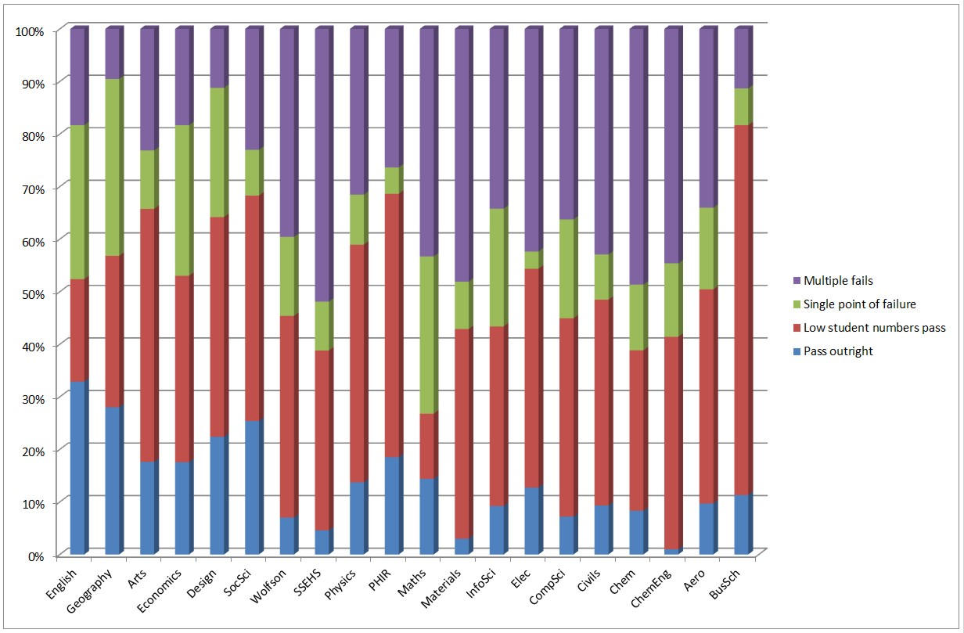

Appendix 2: Minimum Module Online Presence Requirements
Introduction

• The purpose of specifying a minimum module online presence is to ensure a level of consistency across modules, programmes and schools, therefore providing equity and meeting student expectations.

• Schools may adopt their own enhanced module online presence requirements but these should build on the requirements set out below as a baseline.

• The revised minimum module online presence builds on the existing requirement for every module to present certain basic information to students, reflecting increased student expectations and the new focus on ‘efficiency and effectiveness’ with regard to the use of learning technologies. It is a key part of the institutional E-learning Strategy and Implementation Plan.

• Irrespective of the type of module, every UG or PG module currently being delivered should comply with the minimum online presence.

• Regular audits of compliance with the minimum presence will be undertaken by the E-learning Team in the Teaching Centre who will support the schools in taking remedial action as appropriate (eg through staff development activities).

• The minimum presence applies to online support for campus-based modules.
Modules delivered in whole or in part via distance learning have additional requirements.

New Learn module requirements from 2012/13 Semester 1

Learn rollover

Every summer Learn is ‘rolled’ over to the next academic year. The rollover process archives the current year’s modules and the next year’s become available for editing. As of summer 2012, all module content* will be ‘hidden’ from students but available to tutors for updating and editing. It is the tutor’s responsibility to access their Learn modules prior to
start of the module to review and activate the content.

Action: Tutors must access Learn to review and activate the online module content prior to the start of the module. If you do not do this, your students will see an empty
module page.

*This does not apply to non-taught modules, eg Department Information modules.

Module Noticeboard

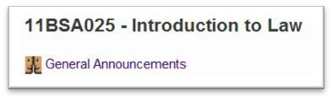

By default, every module includes a Module Noticeboard (previously known as ‘General Announcements’) at the top of the module page. You should use this as the primary mechanism for making announcements to students collectively. Students are not able to
reply to posts made on the Module Noticeboard.

Action: You should use the Module Noticeboard to make announcements to the module cohort.

Action: If you would like your students to be able to communicate via a forum or reply to your posts, you will need to add a forum(s) to your module.

Module Card

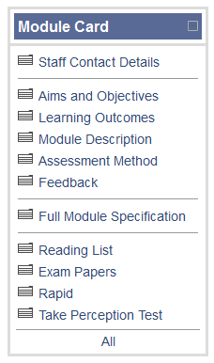
Every module has a ‘Module Card’ block in the left hand column. Some of the items in this block are in part populated automatically by LUSI (the Student Information System) but you will need to add some material as detailed below.

1

2

3

Item | Action
Staff Contact  Details | Action: You need to complete your Learn profile, including your contact details. To do this, once logged in, click on your name to display your profile page. Then click the Edit Profile tab to make changes. This profile is then available across all modules taught by the tutor.
Reading List | Action: You should ensure that there is a reading list hosted on the new Library Reading List system – not uploaded to Learn itself. Guidance on creating reading lists using this system is available at http://learn.lboro.ac.uk/course/view.php?id=3749
Exam Papers | Action: By default, the exam papers for the last three years are available via this link. If this is not appropriate, you need to request that papers be removed / added via  learn@lboro.ac.uk .

Main content area

You may choose to structure this on a week by week or topic by topic basis (and you can do this yourself via ‘Settings’).

Action: No content ‘block’ should be left both visible and empty. EITHER you should hide the block OR you should insert a ‘label’.

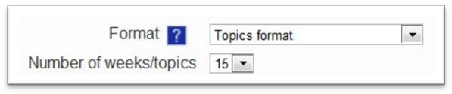

Content area format setting

You are encouraged to make use of the ‘collaborative’ features of Learn, such as Forums and Wikis, in the main content area, but these are optional depending on the learning outcomes of the module.

You are expected to include at least some module resources in the main content area.
These resources may include lecture PowerPoint presentations, lecture notes, spreadsheets, audio clips, video clips, ReVIEW (lecture capture) presentations, Camtasia recordings, glossary of key terms, etc. You may link to resources that are hosted on external websites or upload resources to Learn itself.

It is your choice as to whether to make resources available from the start of the semester or whether to use the new scheduling feature in Learn / Moodle 2 that allows you to ‘release’ resources on certain dates.

When posting content on Learn, it is the responsibility of all staff to ensure that resources do not infringe copyright. You should note that use of Learn and other associated systems is subject to the University Acceptable Use Policy (AUP) and familiarise yourself with this document.

Action: You should include at least some resources in the main content area of every module you ‘own’.

Action: If in doubt about copyright issues, seek advice from support via copyright@lboro.ac.uk .

Beyond the minimum online presence

• Learn has many more powerful features beyond the limited range covered by the minimum module requirements. Staff are strongly encouraged to make use of the support available, from the E-learning Team and others, in identifying further opportunities to enhance both ‘efficiency and effectiveness’.

• In particular, Learn includes:
o Various collaborative functions including forums, chat and wikis which foster interaction and which may encourage students to keep returning to the module page.
o Tools such as Groups, Choice, Assignments and Feedback which can help you to manage your module more efficiently.
o The Quiz tool which provides a quick means to build in formative assessment.
o The Lesson tool which provides a way of creating a structured set of pathways through material; helpful if you have a lot of content.

• Support is using these and other features of Learn is available in the Learn Staffroom module at http://learn.lboro.ac.uk/course/view.php?id=3507 . Every member of staff who is a Tutor or Additional Tutor on a module is automatically enrolled in the Staffroom.

• Module tutors are encouraged to log into each of their modules on Learn regularly during the Semester. Specifically, it may be helpful to check the Participants list for each modules to identify students who have not accessed the module at all (or only rarely). Failure to access Learn by an individual student, when most students are accessing the module regularly, may be an indicator of a wider problem with engagement.

• Where discussion forums are used, module tutors are encouraged to check them regularly to ensure that communication between students remains appropriate at all times.

Other centrally supported systems

The University promotes and supports centrally a range of other learning technologies which may be seen as spokes with Learn at the hub. Several of these systems have been
identified as ‘essential’ in promoting efficiency and effectiveness:

• Turnitin, for originality checking of submitted coursework;
• Grademark (a sub-tool of Turnitin), for online marking;
• QuestionMark Perception, for online assessment;
• OMR (Optical Mark Recognition), for automated paper-based assessment;
• WebPA, for online peer assessment;
• Co-Tutor / Attendant, for recording attendance and tutor interactions with students;
• ReVIEW, for automated lecture capture;
• Blackboard Collaborate (formerly Elluminate), for web conferencing;
• Turning Point, for integrating electronic voting with wireless handsets into Powerpoint presentations;
• Camtasia, for creating narrated screen recordings.
• GoogleApps, for collaborative working.

For all of these tools, Loughborough case studies exist demonstrating how they improve efficiency and effectiveness; the e-learning blog at http://blog.lboro.ac.uk/elearning is a valuable source of information in this respect. Schools are encouraged to promote these learning technologies where pedagogically and / or administratively appropriate within their local policies.

In addition, there are many external Web 2.0 services not covered by any service level agreement with the University but which present valuable opportunities for improving efficiency and effectiveness. Broadly, the institutional position on the use of such services is that staff may exploit them where pedagogically appropriate subject to certain key conditions:

• Use by staff or students of external Web 2.0 services is subject to the AUP.
• You must not require students to have or set up accounts on any external services.
• You should consult your E-learning Officer in the first instance detailing the Web 2.0 service and how you intend to use it.
• The Learn module page should remain the hub of the module’s content and interaction.
• External services must not be used in any way to deliver or support formal assessment.

Further guidance is available via learn@lboro.ac.uk .

Appendix 3: Criteria used in auditing modules

Past exam papers
- Pass in this category only given if an exam paper appears in the past paper database.
- N/A used where the module is coursework only (this could be written essays, lab work, in class tests or CAA tests), or where it is not relevant to the module i.e. a META module.
General Announcements
- Pass only given in this category if there is clear evidence that the GA is present, is in use and visible. GA is denoted as ‘Well Used’ if there are 10-15 separate postings visible.
- Additionally passes have been given where other forums have been created to effectively do the same thing, but allowing a degree of student interaction.
Staff Contact details
- Pass only given in this category if it was easy to find lead tutors’ email addresses, room numbers and telephone numbers.
- Passes were given if this information was found on the module page, in the Staff Contact Details area, in a module content PDF, PPT or Word doc, or in linked staff profile pages on departmental web pages
- A degree of leniency was given to staff contact details on staff profile pages of departmental web pages, due to the current move to the new CMS, hence some links were broken, but only due to this.
Reading lists
- Pass only given if one or more items existed on the official library reading list system.
- Some leniency given to modules like project modules etc., where difficult to define reading lists. These are still marked as failed for the reading list, but may have passed overall.
Content
- Pass only given if module contained module specific content, showing evidence of effort by tutor to provide suitable resources. Here volume is not necessarily the key indicator. Some modules may have few resources that have considerable breadth and depth.
- A degree of leniency was given to those modules where all blocks and their content were hidden, as this implies the tutor may have deliberately hidden it for rollover (due to the fact we are reviewing last year’s content after the rollover)
Visible blocks
- Pass only given if all visible blocks have resources and / or activities in them. N.B. this does not include Block 0.
- If a block has a title or small label, but no resources or activities, it is considered a fail.

