Teacher Education at Loughborough

Summary of our Initial Teacher Education Curriculum

Aims: The PGCE Initial Teacher Education (ITE) curriculum aims to nurture secondary teachers who are not only critically reflective and innovative but also caring and inclusive and who can positively impact the education and lives of young people.

Design: Central to the curriculum's design (see figures below) is its integrated, developmental, and evidence-based approach, which is carefully structured to progressively challenge and equip trainees with the necessary knowledge, understanding, and skills to thrive in their Early Career Teacher (ECT) years and build successful teaching careers. The curriculum is thoughtfully designed to prepare trainees to be well-rounded educators who are confident, well-prepared, and enthusiastic about making meaningful contributions to the development of young people, the teaching profession, and their subject area.

Spanning 36 weeks, the programme is divided into four sequential phases (foundational, emerging, embedding, enhancing), each of which is designed to address and revisit key aspects of the ITE curriculum. This phased approach allows trainees to reflect throughout each developmental stage and progress towards achieving Qualified Teacher Status (QTS). Embedded within and central to the curriculum is the General Professional Studies strand (module), which is a common foundation for both Mathematics and Physical Education, underscoring the importance of a holistic educational approach and perspective.

Subjects: The subject-specific elements of the curriculum are articulated through three key interconnected aspects: Teachers and Teaching, Learners and Learning, and Contexts and Behaviour. These aspects are pivotal in directing trainees' attention towards their evolving practice, emphasizing the intricate link between teachers' actions and learners' needs, motivations, and progress, and the broader educational context, acknowledging that in any pedagogical encounter all dimensions are interacting. This curriculum framework aligns with and expands upon the 5 core areas identified within the Core Content Framework (CCF), ensuring a comprehensive educational experience that exceeds the minimum entitlement.

Learning: The programme offers a rich blend of integrated university-based and school-based learning experiences. University-based learning encompasses a variety of activities, including lectures, seminars, workshops, practical sessions, and peer teaching episodes, all aimed at building a robust theoretical foundation. School-based learning experiences, which span across primary, SEND, and two secondary placements, as well as intensive training and practice (ITaP) days, provide practical, hands-on opportunities for trainees to apply their theoretical knowledge in real-world teaching contexts with the support of expert colleagues. These experiences are carefully curated to include focused discussions, observations, and collaborative teaching exercises, thereby fostering a deep understanding of the relationship between theory and practice.

Significantly, the curriculum is designed with an emphasis on trainee well-being, incorporating directed time for reflection and consolidation of learning experiences as well as the personalisation of learning. This approach enhances both trainees' knowledge and skills and supports their personal and professional development.

Structure: The programme structure, which includes 125 days in schools and 52 days in university, along with four Intensive Training and Practice weeks, ensures a comprehensive and immersive learning experience. The PGCE course specifically spans across two semesters, from September to January (semester 1) and from February to June (semester 2). This structure is designed to ensure a comprehensive coverage of the curriculum and an effective balance between university-based and school-based learning experiences across the academic year. The programme itself is divided into five connected and interrelated university modules, with each module tailored to support trainees' progressive development from the foundational to enhancing curriculum phases.

Conclusion: Our ITE curriculum represents an ambitious, progressive and integrated approach to teacher education. It is designed to equip trainees with the skills, knowledge, and understanding necessary for a successful teaching career, while also emphasizing the importance of personal and professional well-being. Through a combination of theoretical learning and practical application, trainees are prepared to become effective, reflective, and innovative educators who can make a lasting positive impact on the lives of young people.

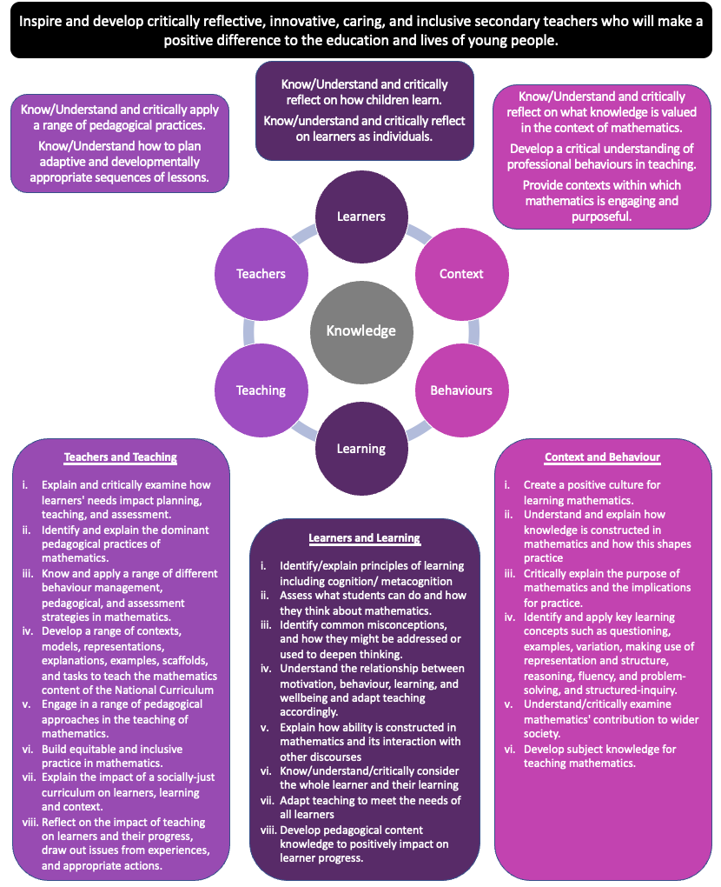
ITE Curriculum Map – Mathematics

Teachers and Teaching reflects the understanding and application of a range of pedagogical tools and approaches to be purposely, selectively and critically applied to meet leaners’ needs.

Context and Behaviours reflects the values, purpose and outcomes of the subject and an appreciation of the social, historical and political factors that influence these. This is also related to knowledge of the professional behaviours required in teaching.

Learners and Learning reflects learners as diverse. It considers pupils’ diverse needs and motivations and the impact of these on how pupils learn.

GPS
1) Understand and explain contemporary school context, curricula (including the National Curriculum) and key whole school issues and policies
2) Understand and demonstrate the professional behaviours, requirements, and expectations of secondary teachers both within and beyond their specialist subject
3) Critically consider how pupils learn, factors which influence pupil learning, and key learning theories and strategies to meet the needs of and support and enhance pupil learning
4) Critically reflect on and discuss pupil learning, pupil differences, and how teaching can be adapted to meet pupils’ diverse needs
5) Engage and reflect on different behaviour management, pedagogical and assessment strategies and innovations and practices.
6) Understand, reflect and demonstrate practical, interpersonal and other skills needed to work effectively with key stakeholders and support pupil learning, development, and wellbeing
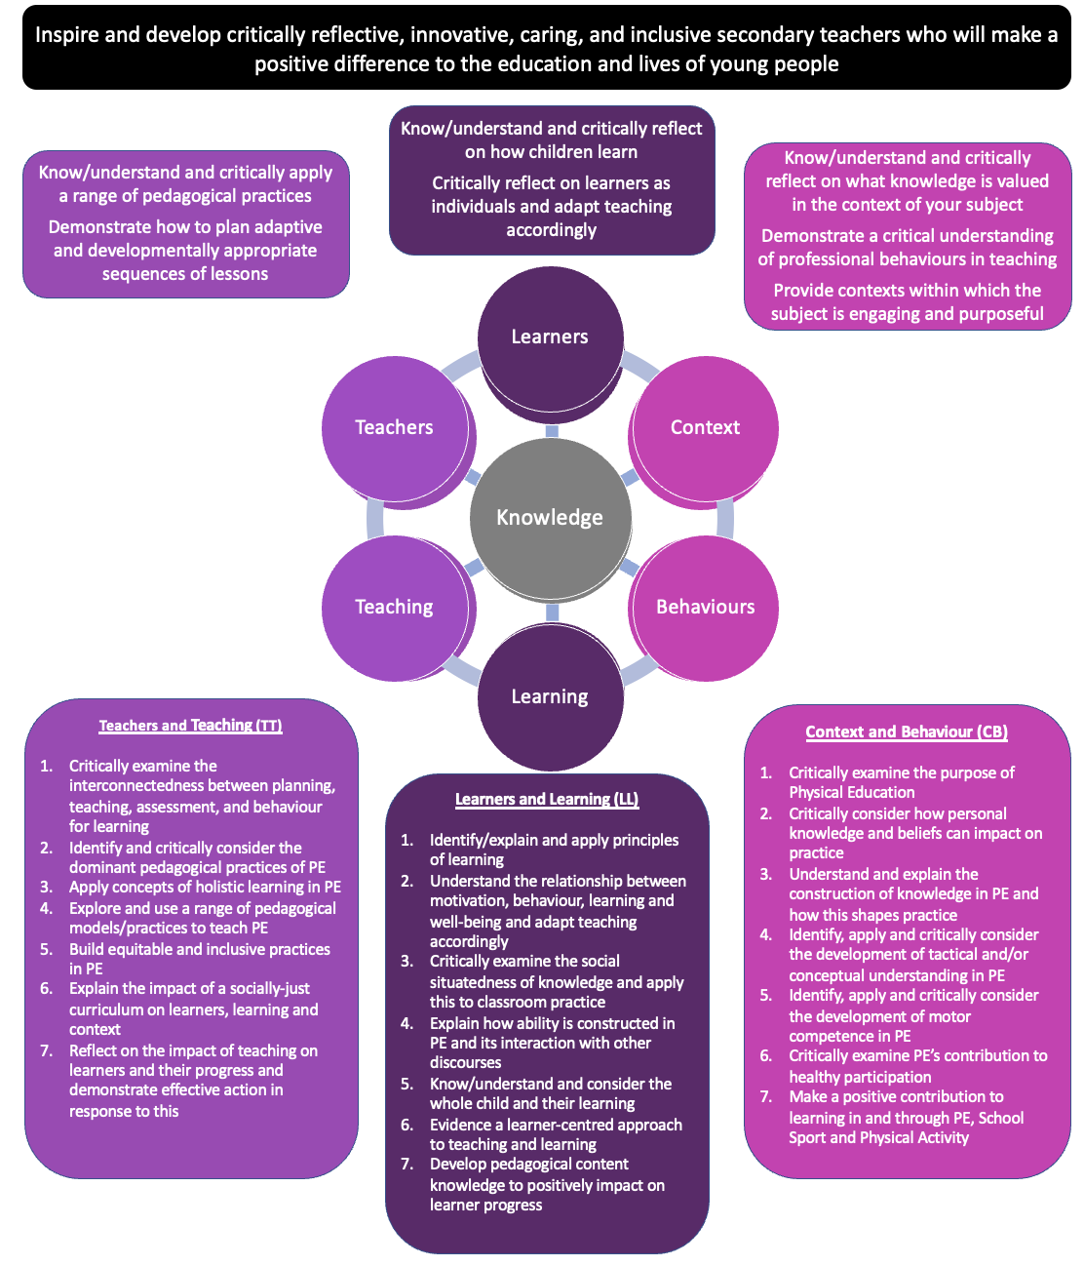
ITE Curriculum Map – Physical Education
GPS
1) Understand and explain contemporary school context, curricula (including the National Curriculum) and key whole school issues and policies
2) Understand and demonstrate the professional behaviours, requirements, and expectations of secondary teachers both within and beyond their specialist subject
3) Critically consider how pupils learn, factors which influence pupil learning, and key learning theories and strategies to meet the needs of and support and enhance pupil learning
4) Critically reflect on and discuss pupil learning, pupil differences, and how teaching can be adapted to meet pupils’ diverse needs
5) Engage and reflect on different behaviour management, pedagogical and assessment strategies and innovations and practices.
6) Understand, reflect and demonstrate practical, interpersonal and other skills needed to work effectively with key stakeholders and support pupil learning, development, and wellbeing
Context and Behaviours reflects the values, purpose and outcomes of the subject and an appreciation of the social, historical and political factors that influence these. This is also related to knowledge of the professional behaviours required in teaching.
Learners and Learning reflects learners as diverse. It considers pupils’ diverse needs and motivations and the impact of these on how pupils learn.
Teachers and Teaching reflects the understanding and application of a range of pedagogical tools and models to be purposely, selectively and critically applied to meet leaners’ needs.

