Learning and Teaching Committee

Subject: Assessing English Language Competency for International Students to ensure they meet minimum UKBA requirements

Origin: Wendy Ferguson, Admissions Office

Summary: This paper summarises the ways in which the University assesses the English language competency of non-EU student to ensure that they meet the minimum level as required by the UK Border Agency for a student visa.

Action Required: Learning and Teaching Committee is asked to confirm its approval for the procedure.

Background: The UK Border Agency (UKBA) Tier 4 Sponsor Guidance (Version 07/12) requires that students being admitted to a degree-level or above course are assessed as being competent in English language at a minimum B2 Level on the Common European Framework of Reference for Languages (CEFR). If the Sponsor is an HEI and the student is being admitted onto a degree level course or above, the HEI is permitted to choose how to assess the student’s English language competency. However, HEIs must ensure that the student is proficient to B2 Level in all four components (Speaking, Listening, Reading, Writing).

If a student has been awarded a degree or equivalent qualification from a majority English language speaking country, or is a national of a majority English language speaking country (as defined by the UKBA Tier 4 Sponsor Guidance) the University is not required to confirm their English language competence at CEFR level B2.

If the Sponsor is not an HEI, or the student is being admitted to a course below degree level, the Sponsor must assess the student’s English language by way of one of the UKBA’s list of recognised English language tests (SELT).

Loughborough University procedure on assessing students’ English language for degree-level study or above
Loughborough University’s standard English language requirements are on the web at: http://www.lboro.ac.uk/international/englang/index.htm (Appendix 1).

Where an student submits a SELT the relevant Admissions Office will ensure that the results are above the minimum CEFR B2 level in all four components. As the University’s minimum English language requirements are higher than the B2 baseline, it is unlikely that students would be accepted with a SELT that does not meet B2 requirements. If an student does submit a SELT with one or more sub-test scores below the B2 requirement, they would not be issued with a CAS for the degree.

If an student submits an English Language qualification that is not on the UKBA SELT list, the University will assess it for competency at B2 level according the following criteria:
- Whether the student is a national of a majority English language speaking country, or has obtained a degree or equivalent qualification from a majority English language speaking country.
- Whether the student is permanently domiciled in a country where English is principally spoken, and
- The student’s school curriculum was taught in English, and
- The English language qualification was taught and examined in English.
- In some cases where students have applied for a Research degree, whether they have publications written in English language.

In the above cases Loughborough University is satisfied that, provided the student achieves a grade at or above the University’s minimum requirement, they meet the CEFR B2 requirement in Reading and Writing through the coursework and examination relating to the qualification, and Speaking and Listening through participating in a curriculum taught in the English language.

In addition, Loughborough University has built up considerable experience of teaching students with non-SELT English language qualifications, and uses this experience to inform its assessment of competency. The University recognises that it is not in either its or the student’s interests to admit anyone to a degree-level course if their English language skills are not at a sufficient level for them to be able to engage effectively with their studies.

Loughborough University procedure on assessing students’ English language for the Art and Design Foundation Programme
As the Art and Design Foundation Programme is below degree-level, the University is required to assess the student’s English language through a Standard English Language Test (SELT) as defined by the UKBA. Students are therefore required to submit a SELT which meets the University’s minimum English language requirements, which itself exceeds CEFR level B2.

Indicating English Language competence on the Confirmation of Acceptance for Studies (CAS) for courses at degree-level or above
Where the student is assessed at having reached B2 level on the CEFR, the CAS will contain the following information (see Appendix 2):
- The SELT not required box will be ticked.
- The reason not required will be because the HEI Sponsor has made the assessment.
- Confirmation that the University has assessed the student as being at CEFR level B2 in all four components will be given in the ‘Evidence used to obtain offer’ box.
- As permitted by the UKBA, students assessed by the University as being at CEFR B2 will not be required to provide documents as evidence of their English language qualification during the visa application process.

Indicating English Language competence on the Confirmation of Acceptance for Studies (CAS) for the Art and Design Foundation programme
Where the student is assessed at having reached B2 level on the CEFR, the CAS will contain the following information (see Appendix 2):
- The SELT required box will be ticked.
- The English language level attained, individual component scores and test provider details will be entered on the CAS.

Changes to UKBA Sponsor Guidance

The University will review the above procedure as and when updates to the Tier 4 Policy and Sponsor Guidance are issued by the UKBA, and will amend its practice if required.

Prepared: 30/11/2012
Appendix 1 - Loughborough University Standard English Language Requirements

UCLES Certificate of Proficiency in English (CPE) | C
UCLES Certificate in Advanced English (CAE) | B
Cambridge English Language syllabus 1119 | C
CSE English Language | 1
GCSE English Language or O Level | C
International GCSE English (IGCSE) /Level 2 Certificate in English language | C
IELTS Academic Test (some Schools /Departments have higher requirements) | overall 6.5 with not less than 6.0 in the individual Listening, Reading, Writing and Speaking tests
International Baccalaureate Diploma (IB): English Standard Level (SL) | 4
NEAB University Entrance Test in English for Speakers of Other Languages (UETESOL) | B
Pearson Test of Academic English (PTE) | 62 overall with no less than 55 in all subtests
Postgraduate degree from a University in the UK | Pass
Scottish Qualifications and Credit Framework: Standard Grade English, Intermediate Grade English, Higher Grade English | C
TOEFL* (internet based test) | 100 overall with no less than 20 in the individual Listening, Reading, Writing and Speaking tests.
Undergraduate degree from a University in the UK. (Postgraduate Research applicants must have a minimum 2:2 classification) | At least one year of study completed in the UK (some programmes require a minimum of two years study completed in the UK)
Undergraduate or Postgraduate degree from one of the following countries: Antigua & Barbuda, Australia, the Bahamas, Barbados, Belize, Canada*, Dominica, Grenada, Guyana, Jamaica, New Zealand, St Kitts & Nevis, St Lucia, St Vincent & the Grenadines, Trinidad & Tobago, USA | Pass Applicants who are not Canadian nationals, but have studied in Canada will need an additional English language test (unless they are nationals of another majority English language speaking country).
University of Reading TEEP | Overall score of 6.5, with not less than 6.0 in individual Listening, Reading, Writing and Speaking tests

International English Language Qualifications where the school curriculum is taught in English:

Country | Qualification | Minimum Grade Required
Australia | Pass English language within Provincial Secondary/Senior School Certificate or Diploma | 50%
Botswana | IGCSE or BGCSE (Botswana General Certificate of Secondary Education) | C
Brunei | Brunei-Cambridge General Certificate of Education Ordinary Level (B-C GCE O Level) | C6
Cameroon | GCE O level | C
Canada | English language within State Senior Secondary Certificate of Education. | 60%
European Baccalaureate | English | 60% (6.0
Hong Kong | Hong Kong Certificate of Education | C
 | Hong Kong Advanced Level Examination Use of English | C
 | Hong Kong Diploma of Secondary Education, Core English | 4
India (undergraduate applications) | Standard XII English with the following minimum marks:
 | CISCE and CBSE Boards | 70%
 | Maharashtra Board and Tamil Nadu and Kanataka | 75%
 | West Bengal | 70%
India (postgraduate applications) | Must meet the University’s standard or higher English language requirement, as specified by the School/Department
Ireland (Eire) | Ardteistimeireacht (Leaving Certificate) Ordinary level. | C3
Kenya | Kenya Certificate of Secondary Education (KCSE). | C
Malawi | Malawi School Certificate of Education (MSCE) | C
Malaysia | Cambridge English Language syllabus 1119 | C
Malta | IGCSE or Secondary Education Certificate Secondary Education Certificate Examinations (SEC) | C
New Zealand | National Certificate in Educational Achievement at level 3 | Achieved (some degrees will require Merit in some subjects)
Singapore | Integrated Programme - students following teh IP must be able to demonstrate English language achievement within their secondary studies
 | Singapore A Levels:
 | H1 Literature in English | C
 | H2 Literature in English | D
 | H2 English Language and Linguistics | D
 | Singapore O Level English | C
 | Ngee Ann Polytechnic, Singapore Computerised English Language Proficiency Test (CELPT). | 7.0
South Africa | National Senior Certificate | 5
Tanzania | Certificate of Secondary Education (CSE). | C
Uganda | Uganda Certificate of Education (UCE) | 6
USA | College Entrance Examination Board, SAT I, Critical Reading and Writing skills | 550 in each test
West Africa (including Nigeria and Ghana) | West African Examination Council Senior School Certificate Examination (WASSCE). | C6
 | Senior School Certificate Education (SSCE). | C6
 | Senior School Certificate Education (SSCE). | C6
West Indies/ Caribbean | Caribbean Examinations Council Secondary Education Certificate (CSEC) | III
 | Bahamas General Certificate of Secondary Education (BGCSE) | C
 | Bermuda Secondary School Certificate (BSSC). | C
Zambia | Zambia School Certificate.
Zimbabwe | Cambridge School Certificate / Certificate of Secondary Education (CSE) | C

Appendix 2 - Indicating English language competence on the CAS for study at degree-level or above

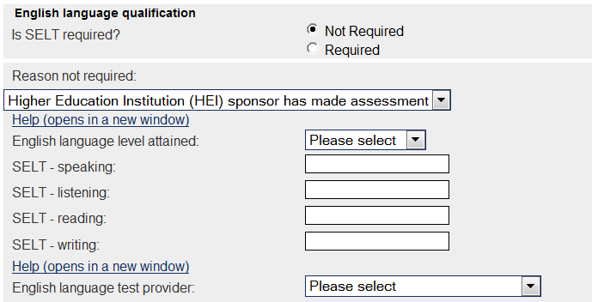

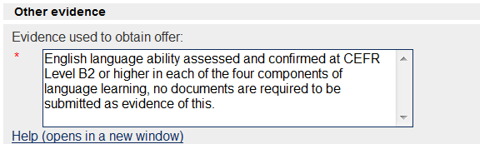

Appendix 3 - Indicating English language competence on the CAS for the Art and Design Foundation Programme (below degree level)

